

List Ranking Summary

|  |  |  |
| --- | --- | --- |
| Thank you for your commitment to becoming a Great Place to Work, and your dedication to your employees.  This report gives you an overview of your list ranking results and provides you high-level feedback to continue making your organization a Great Workplace.  The 2017 Best Small Workplaces list ranks Great Place to Work-Certified companies based on the following three components, ordered from most heavily weighted to least weighted:   1. **Great Place to Work For All** 2. **Executive Team Effectiveness** 3. **Innovation Experience**   Each component is adjusted for ***size and complexity****[1]*relative to the list competitors*.* Data for these components were gathered from employee responses to the Trust Index survey and organization responses to the Culture Audit or Culture Brief questionnaire. |  | We’re Here to Help!  If you have any questions or would like more insight, please reach out to [certify@greatplacetowork.com](mailto:certify@greatplacetowork.com). |

Summary: Best Small Workplaces

Based on data gathered from your Trust Index survey and Culture Audit or Culture Brief, here is your ranking:

|  |  |  |
| --- | --- | --- |
| 2017 Rank  *Estimated* | 2016 Rank | Change |
| 248* | N/A | N/A |

*\* Only 50 companies were ranked on this list. Please do not use this estimated ranking in any promotions or communications about your organization; it is for report reference only.*

Based on your overall results, improvements in your **Great Place to Work For All** score would have had the most significant impact on your 2017 ranking, and improvements in your **Innovation Experience** score would have the least significant impact.

Your List Ranking Component Details: **Great Place to Work FOR ALL**

All employees consistently experience a great place to work, regardless of who they are or what they do in your company.

Your percentile rank in Great Place to Work For All relative to the Best Small Workplaces and the Small-Sized Certified Companies is:

Amongst Best Small Workplaces: better than 0% Amongst Small-Sized Certified Companies: better than 5% 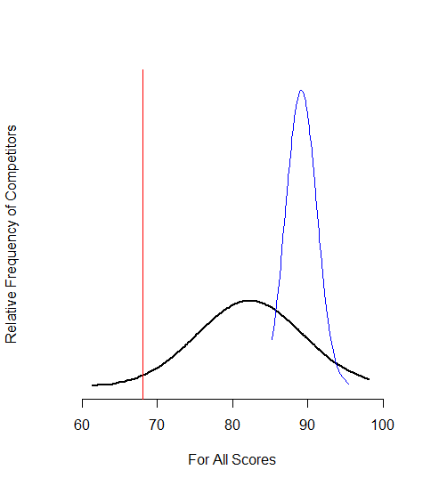

**----** 2017 Small-Sized Certified Companies **----** 2017 Best Small Workplaces **----** Elephant Insurance Services

|  |  |
| --- | --- |
| **What Are We Assessing?** | **Based on What?** |
| **Do employees experience a great place to work?** Do they work for trustworthy, credible leaders who treat people fairly and with respect? Are they proud to be part of your organization? Do they genuinely enjoy spending time with their colleagues? How do these experiences compare to that of other organizations? | All Trust Index Survey Questions |
| **How consistent is the experience of a great place to work in your organization?** Do employees experience a similar work culture, or are there gaps in key differentiating areas based on who people are or what they do? (For example, do individual contributors as well as managers feel their work makes a difference to the organization? Do men and women both find leaders respond directly to their questions?) How do these gaps compare to those of other similar organizations? | All Trust Index Survey Questions (with special emphasis on differentiating survey statements specific to each demographic), analyzed by Managerial Level, Tenure, Birth Year, Gender, Race/Ethnicity, Pay Type, Work Status, LGBT, Disability  Culture Brief Questions providing demographic information |

Your List Ranking Component Details: **Executive Team Effectiveness**

An effective executive team has emotional resonance with their company’s culture and its people, as well as an ability to create a coherent and effective strategy at every level of the business.

Your percentile rank in Executive Team Effectiveness relative to the Best Small Workplaces and the Small-Sized Certified Companies is:

Amongst Best Small Workplaces: better than 0% Amongst Small-Sized Certified Companies: better than 21%

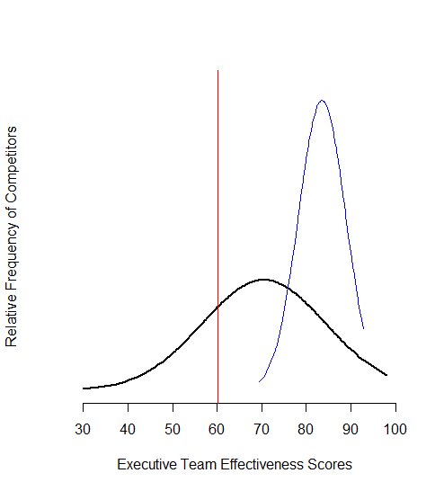

**----** 2017 Small-Sized Certified Companies **----** 2017 Best Small Workplaces **----** Elephant Insurance Services

|  |  |
| --- | --- |
| **What Are We Assessing?** | **Based on What?** |
| **Has the executive team earned employees’ confidence?** What percentage of the team has a great deal of confidence in leaders? Does that confidence level vary or is it shown consistently throughout the business? How does this compare to other organizations? | Trust Index |
| **Does the strategy allow leaders at all levels of the business to be effective?** Do employees believe managers are competent and ethical? How does this compare to other organizations? | Trust Index |
| **Does the leadership team resonate with employees?** Do people throughout the organization find leaders to be approachable and genuinely interested in the welfare of their people? Do leaders’ actions match their words? Do executives embody the best attributes of the organization? How does this compare to other organizations? | Trust Index |

Your List Ranking Component Details: **Innovation Experience**

A culture that enables a company to continuously improve, adapt quickly, and generate game-changing opportunities.

Your percentile rank in Innovation Experience relative to the Best Small Workplaces and the Small-Sized Certified Companies is:

Amongst Best Small Workplaces: better than 0% Amongst Small-Sized Certified Companies: better than 29% 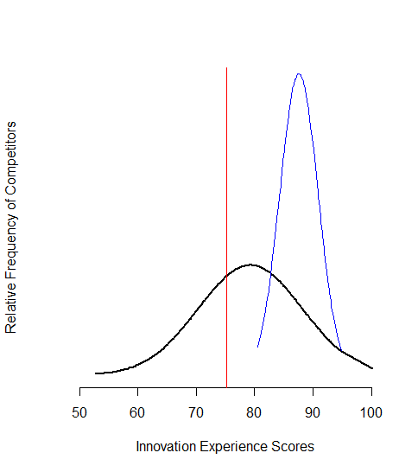

**----** 2017 Small-Sized Certified Companies **----** 2017 Best Small Workplaces **----** Elephant Insurance Services

|  |  |
| --- | --- |
| **Core Aspects** | **Source** |
| **To what extent are employees engaged in innovation?** What percentage of the team reports meaningful opportunities to develop new and better ways of doing things at work? Is this involvement isolated or is distributed throughout the business? Do employees report they are supported when they offer improvements or innovations? How does this compare to other organizations? | Trust Index |
| **Does the company systematically create a culture that supports innovation and improvement?** Do employees report that people cooperate and support each other’s ideas? Does everyone have the opportunity to contribute improvements or does status inhibit involvement? Are leaders clear about the organization’s vision and where people’s ideas are needed? How does this compare to other organizations? | Trust Index |
| **Do individuals feel inspired to contribute?** Do employees feel safe making mistakes? Do leaders seek out their ideas? Are people confident their efforts can make an impact and be rewarded? How does this compare to other organizations? | Trust Index |

**About the 50 Best Small Workplaces**

Over 11,000 US employees provided input to this year’s Best Small Workplaces list.

Great Place to Work analyzed each company’s performance on over 50 survey questions anonymously rated by their staff. All employees were invited to participate in the survey, which is designed to reveal whether the organization is consistently a great place to work for all its people. Meaning:

* Do employees trust the people they work for?
* Are they treated fairly and with respect?
* Are people proud of their work?
* Do they enjoy the folks they work with?
* Are great experiences available to everyone – or does it depend upon who you are and what job you perform?
* How effective are executives at leading the organization and giving everyone an opportunity to innovate and contribute to the organization’s success?
* How does the workplace compare to others of a similar size or industry?

Great Place to Work also collected demographic and program data from companies, but rankings were driven by employee feedback. To be considered, companies had to meet the Great Place to Work-Certified™ standard and their survey results needed at least a 95% confidence level, 6% margin of error. Companies with 10 to 99 employees were considered for the small list and 100 – 999 employees were considered for the medium list.

|  |  |  |
| --- | --- | --- |
|  |  |  |
| For All | Executive Team Effectiveness | Innovation Experience |
| C:\Users\nancy.cesena\AppData\Local\Microsoft\Windows\INetCache\Content.Word\innov2.pngC:\Users\nancy.cesena\AppData\Local\Microsoft\Windows\INetCache\Content.Word\etev2.pngC:\Users\nancy.cesena\AppData\Local\Microsoft\Windows\INetCache\Content.Word\4allv2.png | | |

2017 Best Small Workplaces 2016 Best Small Workplaces

List competitors are consistently setting a higher bar for what it means to be a “*Best* Workplace.” In 2017, Best Small Workplaces outperformed the 2016 Best Small Workplaces on all list components, as illustrated above.

**Why Get Better?**

|  |
| --- |
| Great Place to Work's Certification Program leverages 30 years of data to define and recognize winning workplace cultures. We’re focused on helping companies turn their culture into their business advantage. Our Certification program is designed to help you get to a high-trust, high-performance culture that helps you pinpoint how to better engage your people, strengthen your employer brand, and ultimately grow your business.  Specifically, we’ve found companies with high-trust cultures have **stock market returns 3x greater than average**, companies with high-trust workplaces are **26% more likely to have above average revenue growth** AND across many different industries have **50% lower than average voluntary turnover**.  Each of the specific components we look at to create our lists, not only create great workplaces for employees, but also help drive companies’ businesses. Companies in the top versus bottom quartiles on Great Place to Work For All, Executive Effectiveness and Innovation Experiences, all earn 3x or more year-over-year revenue growth than those in the bottom quartile. And all of that boils down to a better bottom line and a huge advantage – whether you’re working in HR, marketing, or as business leader. |

Learn about upcoming lists here: https://www.greatplacetowork.com/list-calendar.

1. Size and Complexity normalization allows us to fairly compare companies of different sizes and employee populations.